Yumzang Semthuen
Non-Wood Forest Produce Management and Marketing Group (2023-2028)
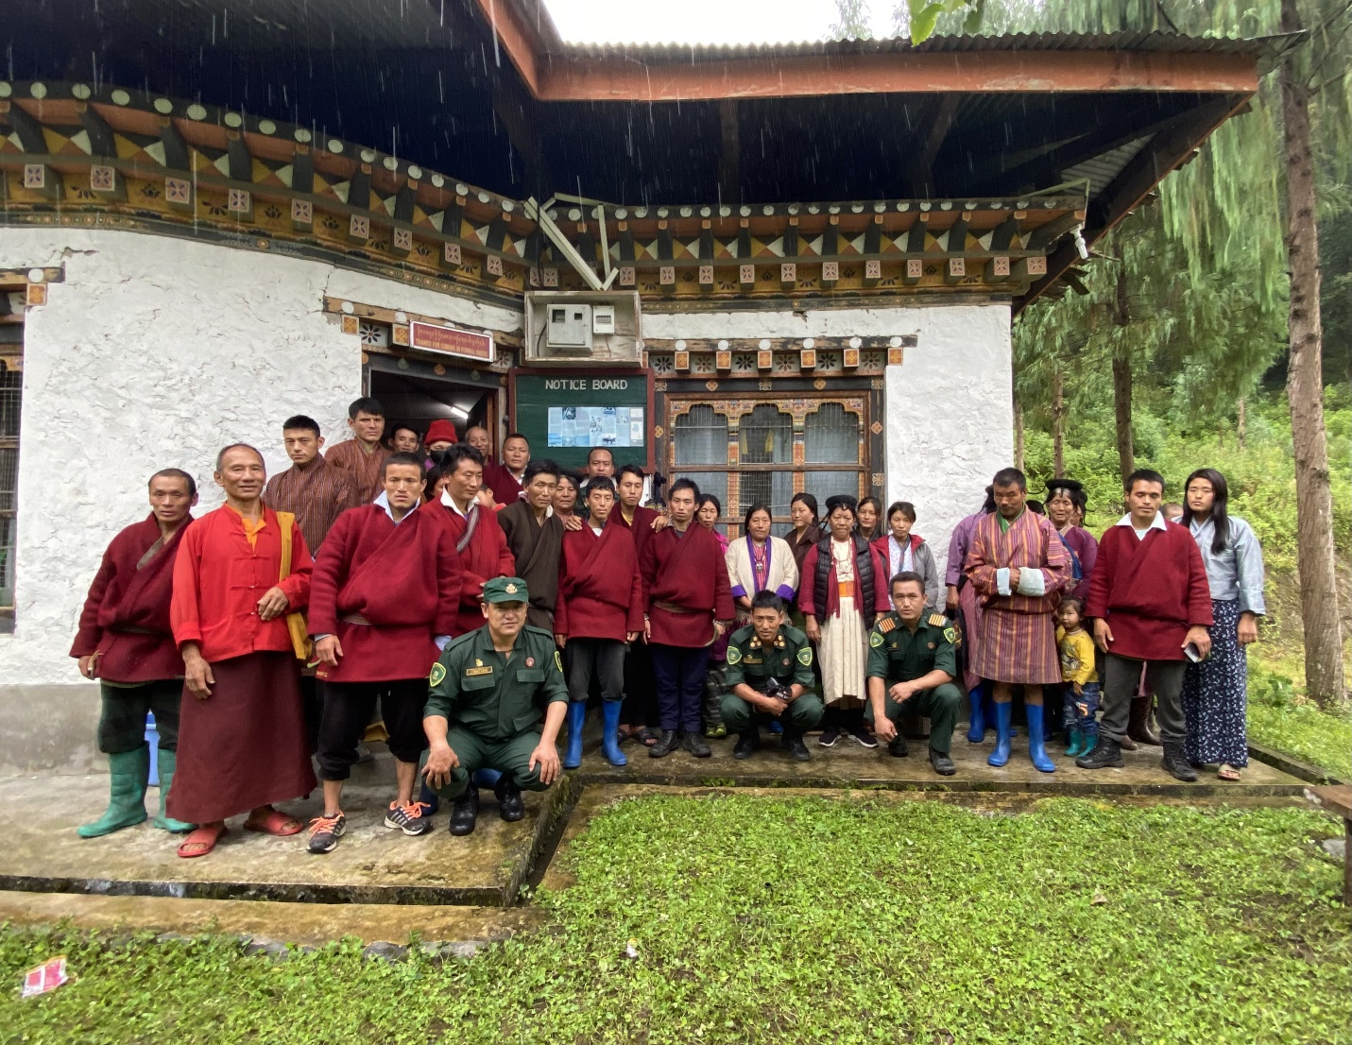
Joenkhar Chiwog, Sakteng Gewog

Sakteng Wildlife Sanctuary
Trashigang
(New Plan)

Table of contents
APPROVAL SHEET 3
Part A: General Information 4
1. Background 4
2. Survey Method 4
3. Goal and objectives 4
4. Description of Species 5
6. Marketing and sales plan 7
7. Marketing arrangements 7
8. Benefits to the member 8
Part B: Group’s BY-LAW 10

List of Tables
Table 1. Detail information on Daphne and its uses 5
Table 2. Harvesting prescriptions for sustainable harvesting of Daphne 6
Table 3. Marketing and sales plan 7
Table 4. Procedure for NWFP harvesting, marketing and sharing of income 8
Table 5. Financial projection from the sale of Daphne 9
Table 6. By-Law for NWFP group 10

List of Figure
Figure 1. Google map of Daphne collection area under Joenkhar Range 7

APPROVAL SHEET

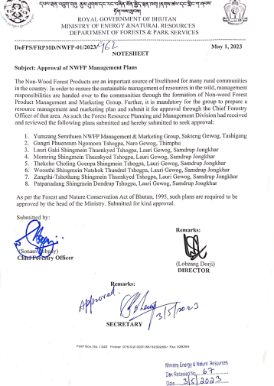

Part A: General Information

Background

Yumzang Semthuen Non-wood Forest Management and Marketing group is the sub-group of the Yumzang Semthuen community forest. The CF was established in 2009 in Joenkhar by Sakteng Wildlife Sanctuary encompassing an area of 450 ha with 55 household members actively participating in community forest management. It falls within Joenkhar Chiwog covering four villages; Joenkhar, Murbee, Serdham, and Bumpalock under Sakteng Gewog. It was established in the year 2009 with plan period of 10 years. The revised CF area covered 352 hectares with 60 households under Joenkhar Chiwog with population of 350.

The area falls under Cool Broadleaved forest with dominant species of Rhododendron arboreum, Quercus lanata, Alnus nepalansis, Schima khasiana and Lyonia species with under growth vegetation of Daphne species. Sokshing, private land, tsamdro and other government institutions located within the CF boundary were all excluded from the CF area. The grazing on Tsamdro within CF area is allowed without any restrictions as per the interest of community and recommendation made from the CFMG members.
The Daphne group will be a part of Yumzang Semthuen community forest where the members of community forest will also be a member of Daphne group and will be allowed to harvest the species as per the guideline within the community forest. The group was formed with an aim to improve the living standard through income generation and allow sustainable harvesting of the species. The marketing of the products shall be done adhering to the bylaws under this management plan.

Survey Method

A participatory mapping was done on Google earth after consultation with the community forest members of Joenkhar range. The area was demarcated, plotted and validated in the field. The total area was calculated using the google earth and the area was divided into 5 blocks namely Jangma Teng, Nuengma Nyesa, Paysang Churong, Bamchen Mo, Rechipa Zor. The area was divided in 5 blocks in order to allow rotational harvesting leading to proper growth of Daphne species. A sampling intensity of 1% was taken from the total estimated area to determine the numbers of plots. A sample plot to plot distance of 100m was determined using QGIS.

Goal and objectives

- Sustainable harvesting of Daphne within the Community Forest.
- Increased income generation to the group through the sale of Daphne.
- Conservation of Daphne species through proper harvesting techniques.

Description of Species

There are 5 species of Deynap in Bhutan: Daphne involucrate, D. bholua, D. sureil, D. retusa and D. ludlowii, and only one species of the genus Edgeworthia, namely Edgeworthia gardneri (Deykap). Both genus belong to the family of Thymelaeaceae. Daphne bholua is a shrub of 1-3.5 m in height and occurs in evergreen oak, spruce, hemlock, fir and blue pine forests at an altitude of 1950-3400 m.

In general Deynap grow well under shade on gentle slopes in moist conditions in rich organic humus overlying well-drained sandy loamy soils. It doesn’t grow well on the southern aspect but thrives well on the other aspects. In general, flowering starts when the plant is about 2-3 years old during January to March while the seeds ripen in September.

For Deynap, under broad leaf forest on north facing slopes at an altitude between 2300 and 2700 m, the average growth is about 0.5 cm in diameter per year. The growth rate of Deynap is slower and coppices well when cut. However, the stem should be cut diagonally to avoid rotting of the remaining stump.

Table 1. Detail information on Daphne and its uses
NWFP name | Harvesting area(s)  (name) | Parts harvested | Use purpose (traditional & others) | Harvesting season (months) | Estimated quantity that can be collected in each season
Daphne bholua  (Deynap) | Jangma Teng, Nuengma Nyesa, Paysang Churong, Bamchen Mo, Rechipa Zor | Bark is harvested at 10cm from ground | Bark is harvested and dried for paper making | March to June | 300 kg of dry weight can be collected from a block per year

- Harvesting prescriptions for sustainable NWFP harvesting

- Cut the stem at 10 cm above the ground to promote regeneration of shoots through a coppice system. As a rule of thumb this is at the height of a fist with the thumb up. The bark is peeled off after the stem is cut.
- Cut the stem slanting to avoid rotting of the remaining stump.
Cut only stems of more than 3 cm in diameter at 10 cm from the ground; it is recommended to harvest as late as possible because the bark increment increases significantly over the years.
- Care should be taken not to destroy/damage the remaining young stands, seedlings and saplings of Deynap and Deykap while harvesting.
- Surrounding trees should not be felled in order to clear the area to ease the harvesting of Deynap and Deykap

- The walking distances from village till the harvesting areas (hours/days): 3 hours
- Estimated size of the harvesting areas (acres or ha) : approximately 108 ha/266 acres
- Estimated quantity of NWFP that can be collected per harvesting season from the area: 300kg
- The NWFP members will harvest Daphne from Jangma Teng block in the 1st year followed by Nuengma Nyesa, Paysang Churong, Bamchen Mo and Rechipa Zor in the 2nd, 3rd, 4th and 5th year respectively. During the first harvesting year except Jangma Teng block, rest of the block will be left undistributed for regeneration.

Table 2. Harvesting prescriptions for sustainable harvesting of Daphne
Name |  | Part(s) harvested | Use(s) | Market |  | Harvesting period | Remarks
Scientific | Local |  |  | Domestic | Export
Daphne bholua | Dheynap (Dz),  Kaga-tey, Kagati, Lokta in (Lh)  Shigushing (Sh),  Sinshing Namakarpo (Traditional medicine) | Bark | Traditional Bhutanese paper | √ | - | March to June | The harvesting area will be divided into 5 blocks for harvesting of Daphne. The harvesting will take place in one block each year and remaining blocks will be left undisturbed for regeneration. This way, the harvesting will be rotated over the five blocks in order to maintain the sustainable harvesting of Daphne resources (Daphne takes 5 years to produce stems of more than 3 cm in diameter)

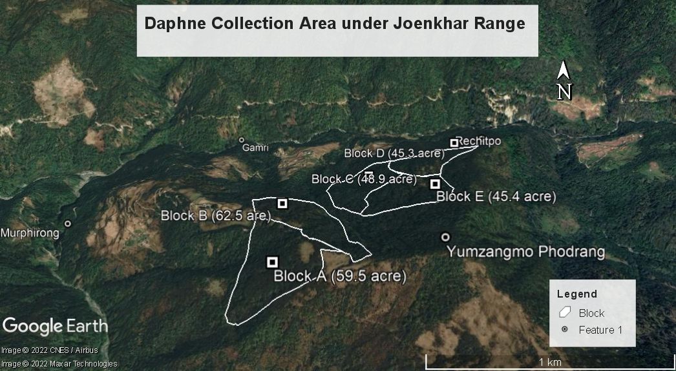
Figure 1. Google map of Daphne collection area under Joenkhar Range

Marketing and sales plan

Daphne, a plant widely used in paper making during ancient times is a species of flowering shrub belonging to family Thymelaeaceae. The Daphne species found in Joenkhar area will be marketed to Trashiyangtse Dzongkhag coordinated by Chairman along with Secretary and treasurer. The group shall harvest an estimated quantity of 300 kg per season and will be sold to the outlet at a price of Nu. 65/kg generating a total revenue of Nu. 19,500 per year.

Table 3. Marketing and sales plan
NWFP | Potential market | Estimated quantity for sale per season (unit) | Form of Products  (dry/fresh) | Expected price per unit | Total (Nu)
Daphne Bholua (Deynap) | Within Bhutan, Trashiyangtse | 300kg | Dry | Nu. 65/kg | Nu.19,500

Marketing arrangements

The group shall harvest the Daphne species on a rotation basis for sustainability and to encourage proper growth. The species shall be harvested from March till June with every members involved in harvesting and collection time. Absentee during collection period will be fined Nu.400 per day. A proper harvesting technique will be used to harvest the species to avoid unnecessary damage to the plant. After drying, the species shall be transported to market lead by Chairman, Secretary and Treasurer. The executive committee responsible for marketing will be admissible of Nu. 500 per day to cover the food expenses and a transportation charge of Nu. 6500 will be incurred for marketing the product to Trashiyangtse. The remnant revenue shall be deposited in the joint bank account.

Table 4. Procedure for NWFP harvesting, marketing and sharing of income
Activity | Procedures
Harvesting of products | Cut the plant at 10 cm above the ground level (the left stump will regenerate in the following growing season).  Cut only stems that are more than 3 cm in diameter.  Do not damage the remaining young stands, seedling and saplings  Do not fell the surrounding trees in order to clear the area to ease harvesting.  Harvesting of Daphne shall be done from March to June
Postharvest practices | Divide harvesting area into 5 blocks for Daphne. Harvesting is rotated over the 5 blocks so that harvesting takes place only in one block per year (Daphne takes 5 years to produce stems of more than 3 cm in diameter). By the time the harvesting rotation reaches the first block, the block becomes harvestable.
Marketing of products | The bark of the Daphne will be harvested and dried. The dried product will be marketed to Trashiyangtse by the executive committee.
Income sharing | The total benefit generated will be deposited in the joint bank account. Daily allowance will be admissible only during the time of marketing.
Raising of community development fund | NA
Payment to committee members for their service | Chairperson, Secretary and Treasurer will be responsible for marketing the products. A daily allowance of Nu. 500/- will be paid per person during the time of marketing/meeting.

Benefits to the member

As projected below (Table 5), the group shall sell an estimated quantity of 300 kg per season and generate a revenue of 19,500 with total benefit of Nu. 12,820. The total profit generated shall be deposited in the joint bank account. An Executive Committee (Chairperson, secretary & treasurer) shall be responsible for planning the marketing of the product and will be admissible for a daily allowance of Nu. 500 during the time of marketing.

Table 5. Financial projection from the sale of Daphne
Sl. No | Particulars | Total Amount (Nu)
 |  | Daphne | ……..
1 | Revenues
a | Total quantity (unit) | 300kg
b | Market price (Nu per unit) | Nu. 65/kg |  | Nu. 19,500/-
c | Total revenues from forest product sales (a*b)
A | Total revenues |  |  | Nu. 19,500/-
2 | Expenses
a | Packaging materials
b | Royalty | Nu. 180 |  | Nu. 180/-
c | Transportation costs | Nu. 6500 |  | Nu. 6500/-
d | Compensation fee to executive committee for marketing products | NA
e | Contribution to community development fund | NA
f | Incidental expenses | NA
B | Total expenses | Nu. 6680 |  | Nu. 6680/-
C | Total benefit (net-income) of group members (total revenues A – total expenses B) |  |  | Nu. 12,820
D | Average income to group members (C/ no of group members) |  |  | Nu. 233
E | Price per unit paid to group members (C/1a) |  |  | 42.7

Part B: Group’s BY-LAW

Table 6. By-Law for NWFP group
NWFP management & marketing group members | Responsibilities and rights of members:  - Participate in planning and decision making process.  - Attend meetings when deemed necessary.  - Contribute labor force during harvesting and collection.  - Elect executive committee.  - Report illegal extraction/sale of Daphne by members or outsiders.  - Right to transparency for resources and financial transaction.
NWFP management and marketing group management committee | Chairperson: Hrangchung, 17363357
Responsibilities of Coordinator/Chairperson:
- Organize and conduct Meeting.
- Act as agent between Government and member for technical and financial support.
- Check the forest produce allotment before approval.
- Have power over monetary control.
- Attend meetings related to NWFP management both within and outside Dzongkhag.
- Resolve conflicts/issues within member and the outsiders.
- Provide clearances after field validation for developmental activities that might be necessary to produce within the area.
- Impose fines and penalties to the offenders.
 | Secretary: Dawa Tshering, 17350252
Responsibilities of Secretary:
- Assist chairman to conduct meeting.
- Keep minutes of meeting.
- Prepare annual work plan in consultation with Chairperson and CFMG management committee.
- Record keeping of collection activity including labour attendance register.
- Present progress report during annual meeting.
- Accompany with Chairman for related work
 | Treasurer: Jamyang Tashi, 17261519
Responsibilities of Treasurer:
- Present annual accounts (income and expenditure) during general meeting.
- Collect annual fees and deposit in common account.
- Keep financial record.
- Present financial report during general meeting.
- Accountability of financial matter related to NWFP.
Tenure of committee member | The executive committee of NWFP group and their tenure will be same as that of community forest which is for three years.
Incentives to the committee members | Executive committee shall be responsible for marketing of the products. A daily allowance of Nu. 500/day will be paid to the marketing team as an incentive and while attending a meeting. However during a meeting if food and lodging are provided, Nu.250/head will be admissible.
Membership Registration fee and annual contribution | A person who becomes a member of CF will become a member of NWFP group by default. An individual shall become a new member after paying new membership entry fee Nu.3000. He/she shall be accepted on contribution of Nu.100/- annually as membership fees.
NWFP group fund management and utilization | The fund generated will be deposited in joint saving account of CF but a separate record book will be maintained.  The expenses for executive committee while marketing the product shall be met from the group fund.

Conflict resolution | In case disputes or conflicts among communities arise about access to certain areas for NWFP harvesting; the matter shall be put to the Gewog Tshogchung (GT) Dzongkhag Tshogdu (DT) for further decision.  Conflicts within the NWFP Management Group, which cannot be resolved by the group members shall be forwarded to the coordinator for settlement. If the case cannot be resolved, it shall be forwarded to the Gewog Administration.  In case there is a conflict between the NWFP Group and outsiders, the case shall be forwarded to the Gewog Administration by the Coordinator.
Meeting and purpose | Meetings will be integrated with the community forest annual meeting to ease expenditure and time.  The group shall meet separately only during the time of emergencies.
Penalties | Absent from work: Nu. 400/- per occasion  Absent from meeting: Nu. 300/- per occasion  Non-members encroaching and collecting the NWFP species will be fined Nu. 100/- per kg (dry weight)  Members not adhering to harvesting guidelines will be fined Nu.65/- per Kg (dry weight)  *Weight will be calculated measuring the diameter at D10 and their corresponding dry weight.

